Experiment No 1
Title: Demonstrate inline, internal, and external JavaScript; use console methods; create a webpage showing user info and a welcome message.
Software/Tools Required: HTML5, CSS3, JavaScript, Visual Studio Code, Google Chrome
<!DOCTYPE html>
<html lang="en">
<head>
<meta charset="UTF-8">
<meta name="viewport" content="width=device-width, initial-scale=1.0">
<title>JavaScript Demonstration</title>

<style>
body{
margin:0;
font-family:Arial, Helvetica, sans-serif;
background:linear-gradient(135deg,#6a11cb,#2575fc);
display:flex;
justify-content:center;
align-items:center;
height:100vh;
}

.container{
width:420px;
background:rgba(255,255,255,0.18);
backdrop-filter:blur(12px);
border-radius:15px;
padding:25px;
text-align:center;
color:white;
box-shadow:0 10px 25px rgba(0,0,0,.3);
}

h1{
margin-bottom:20px;
}

p{
font-size:18px;
margin:10px 0;
}

button{
padding:12px 20px;
margin:10px;
border:none;
border-radius:8px;
cursor:pointer;
background:#00c6ff;
color:white;
font-size:16px;
transition:.3s;
}

button:hover{
background:#0072ff;
}

#welcome{
margin-top:20px;
font-size:20px;
font-weight:bold;
color:#ffff99;
}
</style>

</head>

<body>

<div class="container">

<h1>JavaScript Demonstration</h1>

<p><b>Name:</b> Shubhanshu Manjare</p>

<p><b>PRN:</b>24070521170</p>

<p><b>Department:</b> Computer Science & Engineering</p>

<p><b>College:</b> Symbiosis Institute of Technology</p>

<!-- Inline JavaScript -->
<button onclick="alert('Hello! Welcome to JavaScript.')">
Inline JavaScript
</button>

<!-- Internal JavaScript -->
<button onclick="showMessage()">
Internal JavaScript
</button>

<!-- External JavaScript -->
<button onclick="displayWelcome()">
External JavaScript
</button>

<div id="welcome"></div>

</div>

<script>

function showMessage(){

document.getElementById("welcome").innerHTML =
"✅ This message is displayed using Internal JavaScript.";

console.log("Console Log Example");
console.info("Console Info Example");
console.warn("Console Warning Example");
console.error("Console Error Example");

}

</script>

<script src="script.js"></script>

</body>
</html>
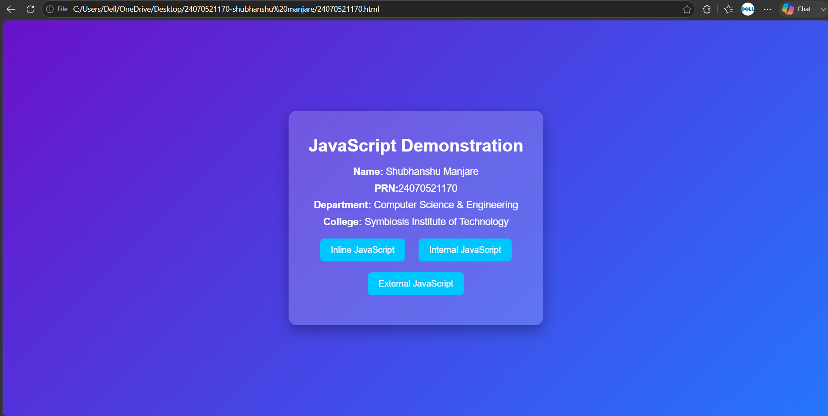

CaseStudy_1
Case Study No.: 1
Title: Create a webpage for college department and link the student information page with it and write a JavaScript program to display "Welcome to SIT Nagpur" in an alert box.
Software/Tools Required: HTML5 , CSS3 , JavaScript , Visual Studio Code , Google Chrome
Student.html
<!DOCTYPE html>
<html lang="en">
<head>
<meta charset="UTF-8">
<meta name="viewport" content="width=device-width, initial-scale=1.0">
<title>Student Information</title>
<style>
*{
margin:0;
padding:0;
box-sizing:border-box;
font-family:Arial, Helvetica, sans-serif;
}
body{
background:linear-gradient(135deg,#0f2027,#203a43,#2c5364);
min-height:100vh;
display:flex;
justify-content:center;
align-items:center;
padding:30px;
}
ontainer{
width:90%;
max-width:950px;
background:rgba(255,255,255,0.12);
backdrop-filter:blur(15px);
-webkit-backdrop-filter:blur(15px);
border-radius:20px;
border:1px solid rgba(255,255,255,0.2);

padding:35px;
box-shadow:0 8px 30px rgba(0,0,0,.4);
animation:fadeIn 1s;
}
h1{
text-align:center;
color:white;
margin-bottom:10px;
}
p{
text-align:center;
color:#ddd;
margin-bottom:25px;
}
table{
width:100%;
border-collapse:collapse;
overflow:hidden;
border-radius:10px;
}
th{
background:#00b4d8;
color:white;
padding:15px;
}
td{
padding:15px;
background:rgba(255,255,255,0.15);
color:white;
text-align:center;
}
tr:nth-child(even) td{
background:rgba(255,255,255,0.08);
}
tbody tr{
transition:.3s;
}
tbody tr:hover{
background:rgba(0,180,216,.4);
transform:scale(1.01);
}
.back-btn{
display:inline-block;
margin-top:25px;
text-decoration:none;

background:#00b4d8;
color:white;

padding:12px 20px;
border-radius:30px;

transition:.3s;
}

.back-btn:hover{

background:#0096c7;
transform:translateY(-3px);
box-shadow:0 5px 15px rgba(0,180,216,.5);
}

@keyframes fadeIn{

from{
opacity:0;
transform:translateY(20px);
}

to{
opacity:1;
transform:translateY(0);
}

}

@media(max-width:700px){

table{
font-size:14px;
}

th,td{
padding:10px;
}

.container{
padding:20px;
}

}

</style>
</head>
<body>
<div class="container">
<h1>🎓 Student Information Directory</h1>

<p>Below is the list of students enrolled in the Computer Science Department.</p>
<table>
<thead>
<tr>
<th>Roll Number</th>
<th>Name</th>
<th>Year</th>
<th>Email</th>
</tr>
</thead>
<tbody>
<tr>
<td>CS101</td>
<td>Alice Smith</td>
<td>3rd Year</td>
<td>alice@college.edu</td>
</tr>

<tr>
<td>CS102</td>
<td>Bob Jones</td>
<td>2nd Year</td>
<td>bob@college.edu</td>
</tr>

<tr>
<td>CS103</td>
<td>Charlie Brown</td>
<td>4th Year</td>
<td>charlie@college.edu</td>
</tr>

<tr>
<td>CS104</td>
<td>David Wilson</td>
<td>1st Year</td>
<td>david@college.edu</td>
</tr>

<tr>
<td>CS105</td>
<td>Emma Watson</td>
<td>3rd Year</td>
<td>emma@college.edu</td>
</tr>

</tbody>

</table>
<center>
<a href="department.html" class="back-btn">⬅ Back to Department Home</a>
</center>
</div>
</body>
</html>
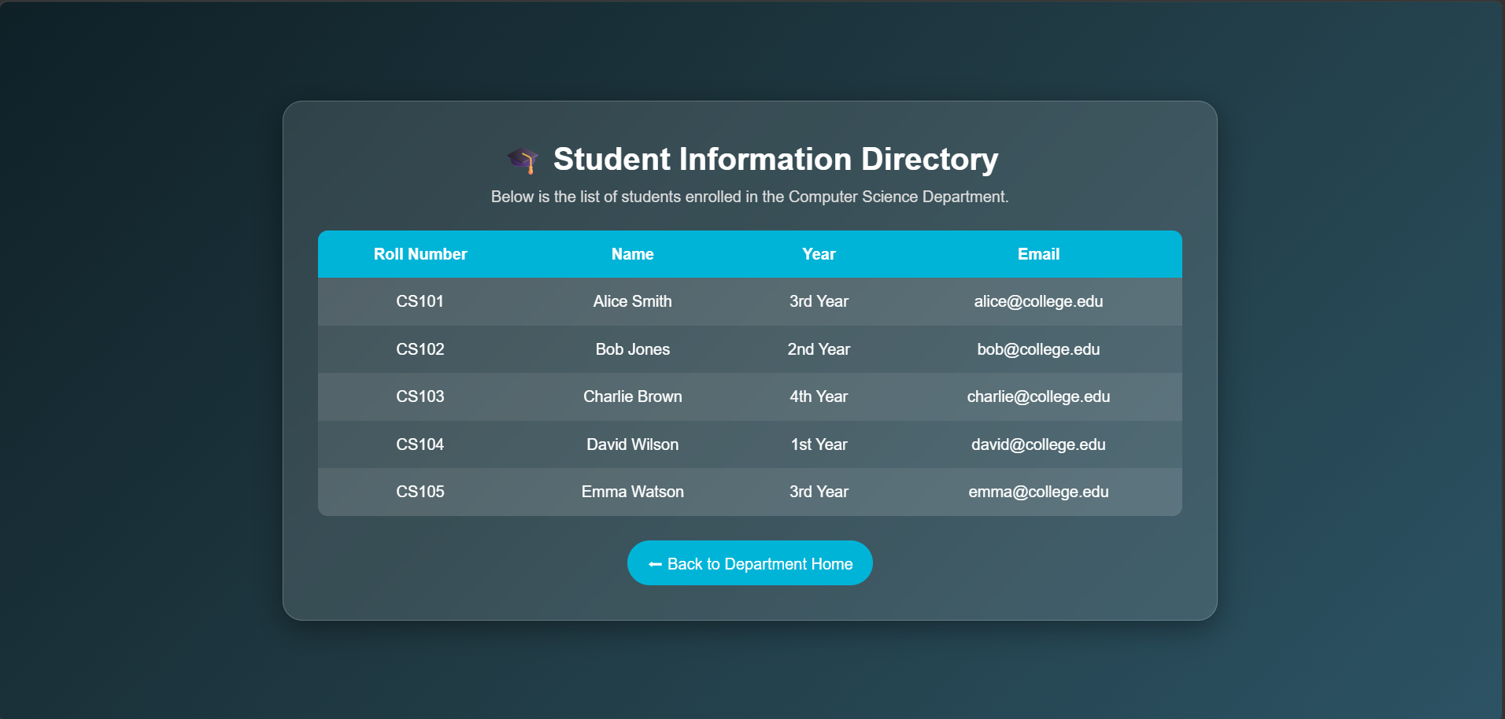

Department.html
<!DOCTYPE html>
<html lang="en">
<head>
<meta charset="UTF-8">
<meta name="viewport" content="width=device-width, initial-scale=1.0">
<title>Computer Science Department</title>
<link rel="stylesheet" href="style.css">
</head>
<body>
<header>
<h1>Symbiosis Institute of Technology</h1>
<p>Nagpur Campus</p>
</header>

<nav>
<a href="department.html">Home</a>
<a href="student_info.html">Student Information</a>
</nav>

<div class="container">
<h2>Computer Science & Engineering Department</h2>
<p>The Computer Science and Engineering Department provides quality education in Programming, Artificial Intelligence, Data Science, Cyber Security, Cloud Computing and Software Development.</p>

<h3>Vision</h3>
<p>To develop skilled engineers with technical knowledge, innovation, leadership and ethical values.</p>

<h3>Mission</h3>
<ul>
<li>Provide quality education.</li>
<li>Encourage research and innovation.</li>
<li>Develop problem-solving skills.</li>
<li>Prepare students for industry.</li>
</ul>

<a href="student_info.html" class="btn">View Student Information</a>
</div>

<script src="script.js"></script>
</body>
</html>

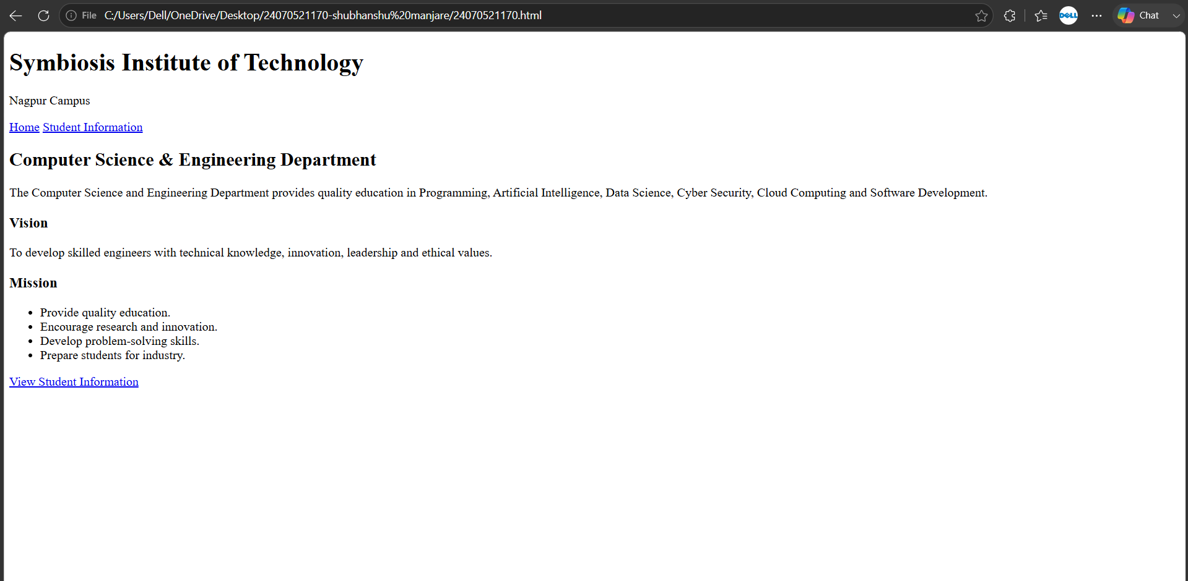

Experiment 2
Use var, let, const, and demonstrate basic features like template literals and destructuring; build a billing calculator with user input.
<!DOCTYPE html>
<html>
<head>
<title>Popup Bill Generator</title>
</head>
<body>

<script>
// 1. Take inputs from the user using popup boxes
var uName = prompt("Enter User Name:");
var contact = prompt("Enter Contact No:");
var pName = prompt("Enter Product Name:");
var qty = prompt("Enter Quantity:");
var price = prompt("Enter Price per Unit:");

// Convert string inputs to numbers for calculation
qty = Number(qty);
price = Number(price);

// 2. Perform calculations
var total = qty * price;
var gst = total * 0.18;
var finalAmount = total + gst;

// 3. Display the layout using document.write
document.write("<h2>Bill Details</h2>");

// Left Half: Details Box
document.write("<div style='width: 45%; float: left; border: 2px solid black; padding: 15px; box-sizing: border-box;'>");
document.write("<h3>Enter Details</h3>");
document.write("<p><b>User Name:</b><br>" + uName + "</p>");
document.write("<p><b>Contact No:</b><br>" + contact + "</p>");
document.write("<p><b>Product Name:</b><br>" + pName + "</p>");
document.write("<p><b>Quantity:</b><br>" + qty + "</p>");
document.write("<p><b>Price per Unit:</b><br>" + price + "</p>");
document.write("</div>");

// Right Half: Receipt Box
document.write("<div style='width: 45%; float: left; border: 2px solid black; padding: 15px; margin-left: 5%; box-sizing: border-box;'>");
document.write("<h3>Bill Receipt</h3>");
document.write("<p>User Name: " + uName + "</p>");
document.write("<p>Contact No: " + contact + "</p>");
document.write("<p>Product Name: " + pName + "</p>");
document.write("<p>Quantity: " + qty + "</p>");
document.write("<p>Price: " + price + "</p>");
document.write("<hr>");
document.write("<p>Total Value: " + total + "</p>");
document.write("<p>GST (18%): " + gst + "</p>");
document.write("<p><b>Final Amount: " + finalAmount + "</b></p>");
document.write("<br>");
document.write("<p>Name: Shubhanshu Manjare , PRN: 24070521170</p>");
document.write("</div>");
</script>

</body>
</html>
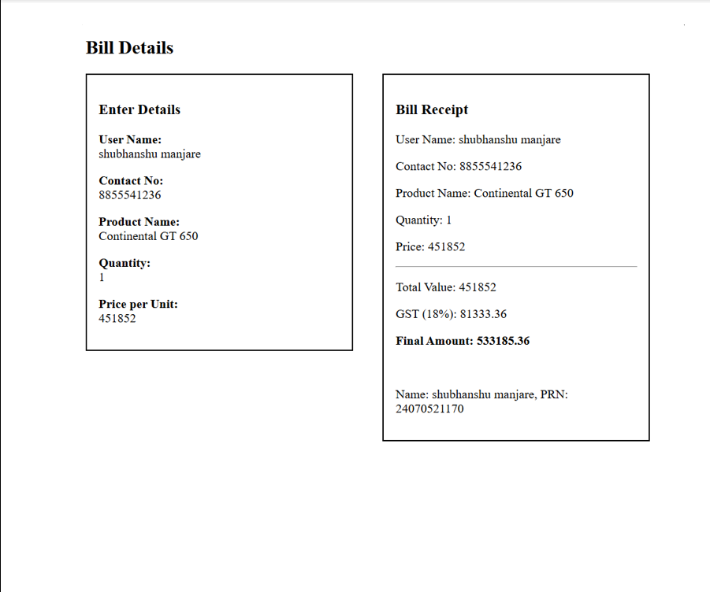

CaseStudy 2
Title: Develop the webpage for an online shopping website with using HTML,CSS and HTML5 tags and calculate the bill using Customer Name, Mobile number, Invoice Number, Product Name, Quality (in Kgs), Rate per Kg(Rs), Discount(%), GST(%), Packing Charges(Rs), Payment Mode (Cash/Card/UPI).
Software/Tools Required: HTML5 , CSS3 , JavaScript , Visual Studio Code , Google Chrome

<!DOCTYPE html>
<html lang="en">
<head>
<meta charset="UTF-8">
<meta name="viewport" content="width=device-width, initial-scale=1.0">
<title>Online Shopping Bill Calculator</title>
<link rel="stylesheet" href="style.css">
</head>
<body>

<div class="container">
<h1>🛒 Online Shopping Bill Calculator</h1>

<form id="billForm">

<div class="row">
<div class="input-box">
<label>Customer Name</label>
<input type="text" id="customer" placeholder="Enter Customer Name" required>
</div>
<div class="input-box">
<label>Mobile Number</label>
<input type="tel" id="mobile" placeholder="Enter Mobile Number" required>
</div>
</div>

<div class="row">
<div class="input-box">
<label>Invoice Number</label>
<input type="text" id="invoice" value="INV2026-001">
</div>
<div class="input-box">
<label>Product Name</label>
<input type="text" id="product" placeholder="Enter Product Name" required>
</div>
</div>

<div class="row">
<div class="input-box">
<label>Quantity (Kg)</label>
<input type="number" id="qty" min="1" value="1">
</div>
<div class="input-box">
<label>Rate per Kg (₹)</label>
<input type="number" id="rate" value="100">
</div>
</div>

<div class="row">
<div class="input-box">
<label>Discount (%)</label>
<input type="number" id="discount" value="5">
</div>
<div class="input-box">
<label>GST (%)</label>
<input type="number" id="gst" value="18">
</div>
</div>

<div class="row">
<div class="input-box">
<label>Packing Charges (₹)</label>
<input type="number" id="packing" value="20">
</div>
<div class="input-box">
<label>Payment Mode</label>
<select id="payment">
<option>Cash</option>
<option>Card</option>
<option>UPI</option>
</select>
</div>
</div>

<button type="button" onclick="generateBill()">Generate Bill</button>

</form>

<div id="bill">
<h2>Invoice</h2>

<table>
<tr><td>Customer Name</td><td id="bname"></td></tr>
<tr><td>Mobile Number</td><td id="bmobile"></td></tr>
<tr><td>Invoice Number</td><td id="binvoice"></td></tr>
<tr><td>Product Name</td><td id="bproduct"></td></tr>
<tr><td>Quantity</td><td id="bqty"></td></tr>
<tr><td>Rate / Kg</td><td id="brate"></td></tr>
<tr><td>Subtotal</td><td id="bsubtotal"></td></tr>
<tr><td>Discount</td><td id="bdiscount"></td></tr>
<tr><td>GST</td><td id="bgst"></td></tr>
<tr><td>Packing Charges</td><td id="bpacking"></td></tr>
<tr><td>Payment Mode</td><td id="bpayment"></td></tr>
<tr class="total"><td>Final Amount</td><td id="btotal"></td></tr>
</table>

</div>
</div>

<script src="script.js"></script>

</body>
</html>

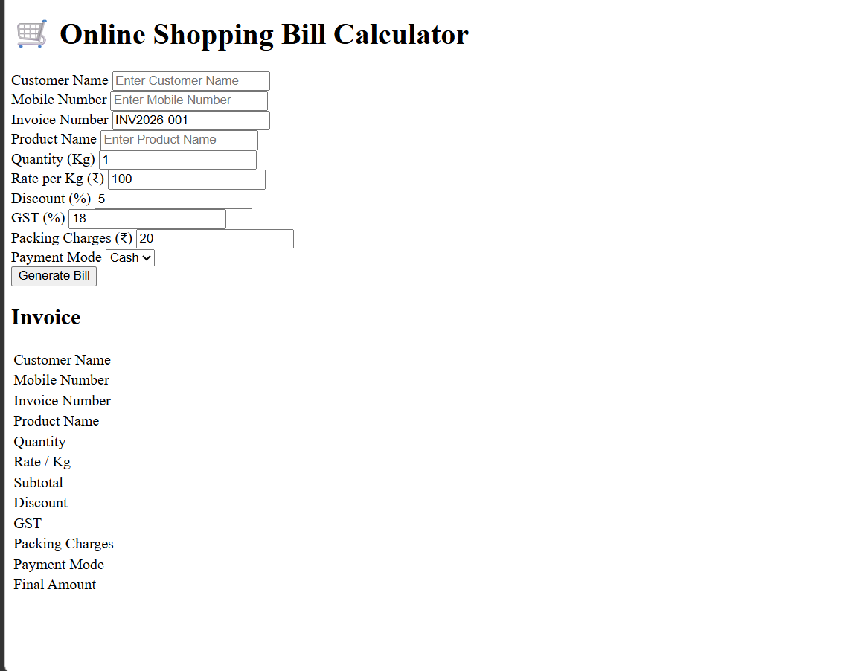

Experiment 3
Title: Implement control structures and form validation; create a grading system based on user-entered marks.
Software/Tools Required: HTML5, CSS3, JavaScript, VS Code, Google Chrome
<!DOCTYPE html>
<html lang="en">
<head>
<meta charset="UTF-8">
<meta name="viewport" content="width=device-width, initial-scale=1.0">
<title>5-Subject Grading System</title>
<style>
* { box-sizing: border-box; font-family: system-ui, -apple-system, sans-serif; }
body { background-color: #f4f6f9; display: flex; justify-content: center; align-items: center; min-height: 100vh; margin: 0; padding: 1.5rem; }
.card { background: #ffffff; padding: 2rem; border-radius: 12px; box-shadow: 0 4px 16px rgba(0,0,0,0.08); width: 100%; max-width: 480px; }
h2 { margin-top: 0; color: #1e293b; text-align: center; }
.grid { display: grid; grid-template-columns: 1fr 1fr; gap: 0.75rem 1rem; }
.form-group { margin-bottom: 0.75rem; }
.full-width { grid-column: span 2; }
label { display: block; margin-bottom: 0.35rem; font-weight: 600; color: #334155; font-size: 0.9rem; }
input[type="number"] { width: 100%; padding: 0.65rem; border: 1px solid #cbd5e1; border-radius: 6px; font-size: 0.95rem; }
input[type="number"]:focus { outline: none; border-color: #2563eb; box-shadow: 0 0 0 3px rgba(37,99,235,0.15); }
button { width: 100%; padding: 0.75rem; background-color: #2563eb; color: white; border: none; border-radius: 6px; font-size: 1rem; font-weight: 600; cursor: pointer; margin-top: 0.5rem; transition: background 0.2s; }
button:hover { background-color: #1d4ed8; }
.error-banner { background-color: #fef2f2; border-left: 4px solid #ef4444; color: #991b1b; padding: 0.75rem; border-radius: 4px; font-size: 0.875rem; margin-bottom: 1rem; display: none; }
.result-box { margin-top: 1.25rem; padding: 1.25rem; border-radius: 8px; display: none; }
.result-header { font-size: 1.1rem; font-weight: 700; margin-bottom: 0.5rem; text-align: center; }
.result-details { font-size: 0.95rem; line-height: 1.5; }
/* Dynamic Theme Colors */
.grade-A { background-color: #dcfce7; color: #166534; border: 1px solid #bbf7d0; }
.grade-B { background-color: #e0f2fe; color: #075985; border: 1px solid #bae6fd; }
.grade-C { background-color: #fef9c3; color: #854d0e; border: 1px solid #fef08a; }
.grade-D { background-color: #ffedd5; color: #9a3412; border: 1px solid #fed7aa; }
.grade-F { background-color: #fee2e2; color: #991b1b; border: 1px solid #fca5a5; }
</style>
</head>
<body>

<div class="card">
<h2>Student Assessment</h2>

<!-- Unified Error Banner -->
<div id="errorBanner" class="error-banner"></div>

<form id="gradeForm" novalidate>
<div class="grid">
<div class="form-group">
<label for="sub1">Mathematics</label>
<input type="number" id="sub1" class="subject-input" placeholder="0 - 100">
</div>
<div class="form-group">
<label for="sub2">Science</label>
<input type="number" id="sub2" class="subject-input" placeholder="0 - 100">
</div>
<div class="form-group">
<label for="sub3">English</label>
<input type="number" id="sub3" class="subject-input" placeholder="0 - 100">
</div>
<div class="form-group">
<label for="sub4">History</label>
<input type="number" id="sub4" class="subject-input" placeholder="0 - 100">
</div>
<div class="form-group full-width">
<label for="sub5">Computer Science</label>
<input type="number" id="sub5" class="subject-input" placeholder="0 - 100">
</div>
</div>
<button type="submit">Calculate Final Results</button>
</form>

<div id="resultBox" class="result-box">
<div id="resultHeader" class="result-header"></div>
<div id="resultDetails" class="result-details"></div>
</div>
</div>

<script>
document.getElementById('gradeForm').addEventListener('submit', function(e) {
e.preventDefault();

const inputs = document.querySelectorAll('.subject-input');
const errorBanner = document.getElementById('errorBanner');
const resultBox = document.getElementById('resultBox');
const resultHeader = document.getElementById('resultHeader');
const resultDetails = document.getElementById('resultDetails');

// Reset UI state
errorBanner.style.display = 'none';
resultBox.style.display = 'none';
resultBox.className = 'result-box';

const scores = [];
let hasFailedSubject = false;

// --- 1. CONTROL STRUCTURE: Loop with Validation Checks ---
for (let i = 0; i < inputs.length; i++) {
const value = inputs[i].value.trim();
const label = inputs[i].previousElementSibling.textContent;

// Check empty input
if (value === '') {
showError(`Please fill in marks for <strong>${label}</strong>.`);
inputs[i].focus();
return;
}

const score = Number(value);

// Check invalid numbers or out-of-bounds inputs
if (isNaN(score) || score < 0 || score > 100) {
showError(`Invalid mark for <strong>${label}</strong>. Enter a value between 0 and 100.`);
inputs[i].focus();
return;
}

// Check for subject failure condition (e.g., passing mark is 40)
if (score < 40) {
hasFailedSubject = true;
}

scores.push(score);
}

// --- 2. CALCULATIONS ---
const totalMarks = scores.reduce((sum, current) => sum + current, 0);
const percentage = (totalMarks / (scores.length * 100)) * 100;

// --- 3. CONTROL STRUCTURE: Grading Logic ---
let grade = '';
let status = '';
let cssClass = '';

if (hasFailedSubject) {
// Essential academic condition: Failing any individual subject overrides average grade
status = 'FAILED (Failed 1 or more subjects)';
grade = 'F';
cssClass = 'grade-F';
} else if (percentage >= 90) {
status = 'PASSED';
grade = 'A+ (Outstanding)';
cssClass = 'grade-A';
} else if (percentage >= 80) {
status = 'PASSED';
grade = 'A (Excellent)';
cssClass = 'grade-A';
} else if (percentage >= 70) {
status = 'PASSED';
grade = 'B (Good)';
cssClass = 'grade-B';
} else if (percentage >= 60) {
status = 'PASSED';
grade = 'C (Satisfactory)';
cssClass = 'grade-C';
} else if (percentage >= 50) {
status = 'PASSED';
grade = 'D (Pass)';
cssClass = 'grade-D';
} else {
status = 'FAILED';
grade = 'F (Needs Improvement)';
cssClass = 'grade-F';
}

// --- 4. RENDER OUTPUT ---
resultHeader.textContent = `Status: ${status}`;
resultDetails.innerHTML = `
<strong>Total Marks:</strong> ${totalMarks} / 500<br>
<strong>Overall Percentage:</strong> ${percentage.toFixed(2)}%<br>
<strong>Final Grade:</strong> ${grade}<br>
<hr style="margin: 0.75rem 0; border: none; border-top: 1px dashed rgba(0,0,0,0.2);">
<strong>Student Name:</strong> Shubhanshu Manjare<br>
<strong>PRN:</strong> 24070521170
`;

resultBox.classList.add(cssClass);
resultBox.style.display = 'block';
});

function showError(htmlMessage) {
const errorBanner = document.getElementById('errorBanner');
errorBanner.innerHTML = htmlMessage;
errorBanner.style.display = 'block';
}
</script>
</body>
</html>
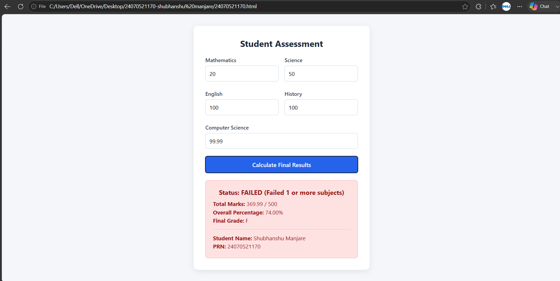

CaseStudy 3
Title: Student Grading System with Login Authentication and Form Validation using HTML, CSS, and JavaScript
Software/Tools Required: HTML5 , CSS3 , JavaScript , Visual Studio Code , Google Chrome
<!DOCTYPE html>
<html lang="en">
<head>
<meta charset="UTF-8">
<meta name="viewport" content="width=device-width, initial-scale=1.0">
<title>Student Login</title>
<link rel="stylesheet" href="style.css">
</head>
<body>
<div class="container">
<h1>🎓 Student Grading System</h1>
<h2>Login Portal</h2>
<form id="loginForm">
<div class="input-group">
<label>Student Name</label>
<input type="text" id="studentName" placeholder="Enter Student Name" required>
</div>
<div class="input-group">
<label>PRN Number</label>
<input type="text" id="prn" placeholder="Enter PRN Number" required>
</div>
<div class="input-group">
<label>Email ID</label>
<input type="email" id="email" placeholder="Enter Email" required>
</div>

<div class="input-group">
<label>Password</label>
<input type="password" id="password" placeholder="Enter Password" required>
</div>
<button type="submit">Login</button>
</form>
<p id="message"></p>
</div>
<script src="login.js"></script>
</body>
</html>

Experiment 4
Title: Use function types, scope, and closures; apply try-catch; build a palindrome checker.
Software/Tools Required: HTML5, CSS3, JavaScript, VS Code, Google Chrome
<!DOCTYPE html>
<html lang="en">
<head>
<meta charset="UTF-8">
<meta name="viewport" content="width=device-width, initial-scale=1.0">
<title>Palindrome Checker</title>
<style>
body{
font-family:Arial,sans-serif;
background:#f4f4f4;
display:flex;
justify-content:center;
align-items:center;
height:100vh;
}
.container{
background:white;
padding:30px;
border-radius:10px;
box-shadow:0 0 10px rgba(0,0,0,0.2);
text-align:center;
width:350px;
}
input{
width:90%;
padding:10px;
margin:15px 0;
font-size:16px;
}
button{
padding:10px 20px;
background:#007bff;
color:white;
border:none;
border-radius:5px;
cursor:pointer;
}

button:hover{
background:#0056b3;
}

#output{
margin-top:20px;
font-size:18px;
font-weight:bold;
}
</style>
</head>
<body>
<div class="container">
<h2>Palindrome Checker</h2>
<input type="text" id="word" placeholder="Enter a word">
<button onclick="checkPalindrome()">Check</button>

<p id="output"></p>
</div>
<script>
// Function Declaration
function cleanText(text){
return text.toLowerCase().replace(/[^a-z0-9]/g,"");
}
// Function Expression
const reverseText=function(str){
return str.split("").reverse().join("");
};
// Arrow Function
const isPalindrome=text=>cleanText(text)===reverseText(cleanText(text));
// Closure
function message(){
let heading="Result : ";
return function(result){
return heading+result;
};}
const displayMessage=message();
// Main Function
function checkPalindrome(){
try{
let input=document.getElementById("word").value;
let output=document.getElementById("output");
if(input.trim()==""){
throw "Please enter a word.";
}
if(isPalindrome(input)){
output.innerHTML=displayMessage("Palindrome ✅");
output.style.color="green";
}
else{
output.innerHTML=displayMessage("Not a Palindrome ❌");
output.style.color="red";
}
}
catch(error){
document.getElementById("output").innerHTML=error;
document.getElementById("output").style.color="orange";
}
}
</script>
</body>
</html>
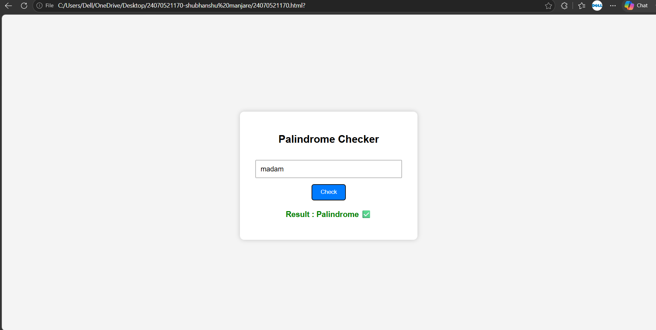
CaseStudy 4
Title: Use function types, scope, and closures; apply try-catch; build a password strength checker using palindrome then display strong or weak password and generate a html and js code.
Software/Tools Required: HTML5, CSS3, JavaScript, VS Code, Google Chrome
<!DOCTYPE html>
<html lang="en">
<head>
<meta charset="UTF-8">
<meta name="viewport" content="width=device-width, initial-scale=1.0">
<title>Smart PIN Security Checker</title>

<style>

*{
margin:0;
padding:0;
box-sizing:border-box;
font-family:'Segoe UI',sans-serif;
}

body{

display:flex;
justify-content:center;
align-items:center;

height:100vh;

background:linear-gradient(135deg,#4facfe,#00f2fe,#43e97b);

}

.container{

width:380px;

padding:35px;

text-align:center;

background:rgba(255,255,255,0.15);

backdrop-filter:blur(18px);
-webkit-backdrop-filter:blur(18px);
border:1px solid rgba(255,255,255,0.3);
border-radius:25px;
box-shadow:0 10px 30px rgba(0,0,0,.25);
}
h2{
color:white;
margin-bottom:10px;

}
p{
color:#f1f1f1;
margin-bottom:20px;
}
.icon{
font-size:55px;
margin-bottom:10px;

}
input[type="text"]{
width:100%;
padding:14px;
border:none;
outline:none;
border-radius:15px;
background:rgba(255,255,255,0.2);
color:white;
font-size:18px;
text-align:center;
margin-bottom:20px;
}
input::placeholder{
color:#eee;
}
button{
width:100%;
padding:14px;
border:none;
border-radius:15px;
background:rgba(255,255,255,0.25);
color:white;
font-size:17px;
cursor:pointer;
transition:.3s;
}
button:hover{
background:white;
color:#0077ff;
transform:scale(1.03);
}
#result{
margin-top:20px;
padding:15px;
border-radius:12px;
font-size:18px;

font-weight:bold;
display:none;
}
.weak{
background:rgba(255,0,0,.2);
color:#ff4d4d;
border:1px solid rgba(255,0,0,.3);
}
.strong{
background:rgba(0,255,100,.2);
color:#00ff88;
border:1px solid rgba(0,255,100,.3);
}
</style>
</head>
<body>
<div class="container">
<div class="icon">🔒</div>
<h2>Smart PIN Security Checker</h2>
<p>Enter your PIN to verify its security level.</p>
<input type="text"
id="pinInput"
maxlength="8"
placeholder="Enter your PIN">
<button onclick="checkPinStrength()">
Check PIN
</button>
<div id="result"></div>
</div>
<script>
function checkPinStrength(){
let pin=document.getElementById("pinInput").value;
let result=document.getElementById("result");
result.style.display="block";
if(pin==""){
result.innerHTML="⚠ Please enter your PIN.";
result.className="weak";
return;
}
// Reverse PIN
let reverse=pin.split("").reverse().join("");
// Extra Conditions
if(pin===reverse){
result.innerHTML="❌ Weak PIN <br>Palindrome PIN detected.";
result.className="weak";
}
else if(pin.length<4){
result.innerHTML="⚠ PIN should contain at least 4 digits.";
result.className="weak";
}
else{
result.innerHTML="✅ Strong PIN <br>Your PIN is secure.";
result.className="strong";
}
}
</script>
</body>
</html>
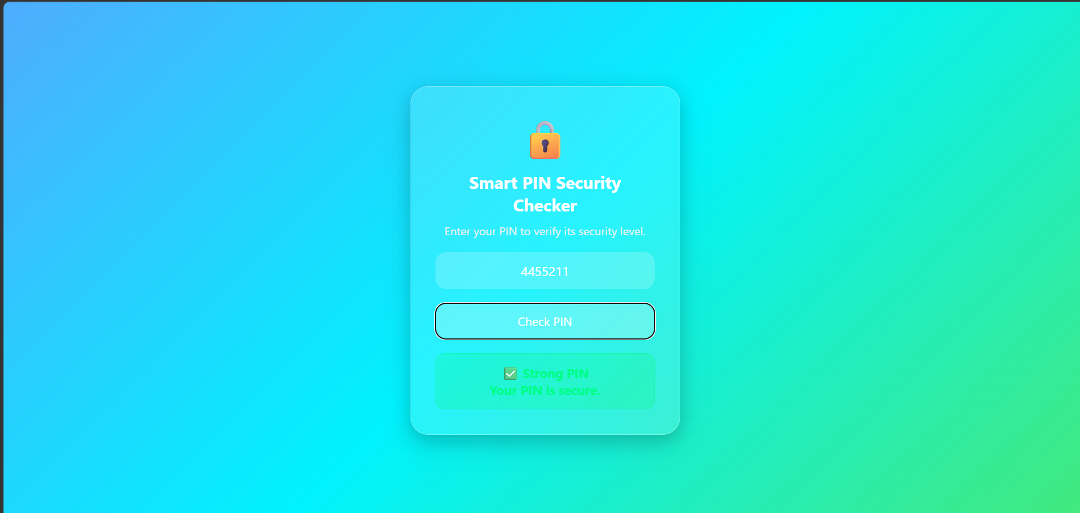

Experiment no 5
Aim : Apply array methods and object handling, create a cart total calculator with discount logic
Theory: JavaScript provides high-order array methods and object manipulation capabilities to model real-world data structures efficiently. Objects allow grouping related key-value pairs—such as product names, prices, and quantities—into structured data models. Native JavaScript array methods like .map() transform dataset arrays into dynamic visual representations (such as HTML table rows), .filter() creates new arrays by excluding specific elements (enabling item deletion), and .reduce() aggregates multi-item values into a single total amount. Additionally, control logic can be chained with these calculations to dynamically evaluate threshold conditions—such as applying tiered percentage discounts based on total order values. In this experiment, these concepts are combined to build a shopping cart calculator that processes item object arrays, evaluates tier-based discount rules, and updates the final payable amount on the DOM in real time.
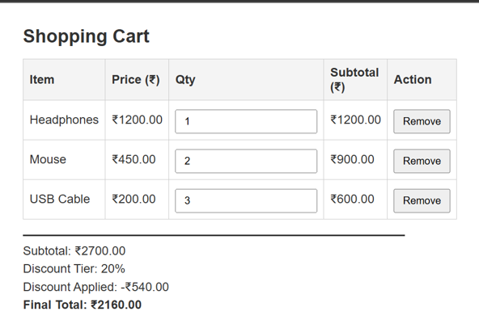
Result:
The shopping cart total calculator was successfully implemented using JavaScript array methods (.map(), .filter(), .reduce()) and object handling. The application accurately computes cart subtotals, handles item removal, and applies slab discounts (10% at ₹1,000, 20% at ₹2,000, and 30% at ₹3,000+) to update the final total in real time.
Conclusion:
This experiment highlights how array methods and object-oriented data structures simplify data manipulation and aggregation in JavaScript. Combining these methods with conditional discount logic enables efficient client-side calculations and dynamic DOM updates for interactive web applications.
Case Study 5
Aim:

<!DOCTYPE html>
<html lang="en">
<head>
<meta charset="UTF-8">
<meta name="viewport" content="width=device-width, initial-scale=1.0">
<title>Interactive Arrays & Loops</title>
<!-- Google Font for modern typography -->
<link href="https://fonts.googleapis.com/css2?family=Inter:wght@400;500;600;700&display=swap" rel="stylesheet">

<style>
:root {
--primary: #4f46e5;
--primary-hover: #4338ca;
--bg-main: #f8fafc;
--card-bg: #ffffff;
--text-main: #0f172a;
--text-muted: #64748b;
--border-color: #e2e8f0;

--danger: #ef4444;
--danger-hover: #dc2626;
--success: #10b981;
--success-hover: #059669;
--accent: #0284c7;
--accent-hover: #0369a1;

--radius-sm: 8px;
--radius-md: 12px;
--radius-lg: 16px;
--shadow-sm: 0 1px 3px rgba(0,0,0,0.05);
--shadow-md: 0 4px 12px -2px rgba(0, 0, 0, 0.08);
}

* {
box-sizing: border-box;
}

body {
font-family: 'Inter', -apple-system, BlinkMacSystemFont, sans-serif;
margin: 0;
background: var(--bg-main);
color: var(--text-main);
line-height: 1.5;
}

/* Header UI */
header {
background: linear-gradient(135deg, #1e293b 0%, #0f172a 100%);
color: white;
padding: 40px 20px;
text-align: center;
border-bottom: 1px solid #334155;
}

.header-badge {
display: inline-block;
background: rgba(255, 255, 255, 0.1);
color: #38bdf8;
padding: 4px 12px;
border-radius: 20px;
font-size: 12px;
font-weight: 600;
letter-spacing: 0.5px;
margin-bottom: 10px;
}

header h1 {
margin: 0 0 8px 0;
font-size: 30px;
font-weight: 700;
}

header p {
margin: 0;
color: #94a3b8;
font-size: 15px;
}

/* Main Layout */
.container {
width: 92%;
max-width: 900px;
margin: 30px auto;
}

.section {
background: var(--card-bg);
padding: 28px;
margin-bottom: 24px;
border-radius: var(--radius-lg);
border: 1px solid var(--border-color);
box-shadow: var(--shadow-md);
}

.section h2 {
color: var(--text-main);
margin-top: 0;
margin-bottom: 6px;
font-size: 20px;
font-weight: 700;
}

.section-desc {
margin-top: 0;
margin-bottom: 20px;
color: var(--text-muted);
font-size: 14px;
}

/* Array Displays */
.array-display {
background: #0f172a;
color: #38bdf8;
padding: 16px 20px;
border-radius: var(--radius-md);
font-family: 'Courier New', Courier, monospace;
font-size: 20px;
font-weight: bold;
margin: 16px 0;
text-align: center;
letter-spacing: 1px;
box-shadow: inset 0 2px 4px rgba(0,0,0,0.3);
}

.static-array {
background: #1e293b;
color: #a7f3d0;
}

/* Inputs & Form Layout */
.control-row {
display: flex;
gap: 10px;
margin-bottom: 15px;
}

.control-row input {
flex: 1;
}

input {
padding: 10px 14px;
border: 1px solid var(--border-color);
border-radius: var(--radius-sm);
font-size: 14px;
outline: none;
transition: border-color 0.2s, box-shadow 0.2s;
}

input:focus {
border-color: var(--primary);
box-shadow: 0 0 0 3px rgba(79, 70, 229, 0.15);
}

.input-stack {
display: flex;
flex-direction: column;
gap: 10px;
margin-top: 12px;
}

/* Buttons Styling */
.btn {
padding: 10px 16px;
border: none;
border-radius: var(--radius-sm);
font-size: 14px;
font-weight: 600;
cursor: pointer;
transition: background 0.2s, transform 0.1s;
display: inline-flex;
align-items: center;
justify-content: center;
}

.btn:hover {
transform: translateY(-1px);
}

.btn-primary { background: var(--primary); color: white; }
.btn-primary:hover { background: var(--primary-hover); }

.btn-danger { background: var(--danger); color: white; }
.btn-danger:hover { background: var(--danger-hover); }

.btn-success { background: var(--success); color: white; }
.btn-success:hover { background: var(--success-hover); }

.btn-accent { background: var(--accent); color: white; }
.btn-accent:hover { background: var(--accent-hover); }

.btn-outline-danger {
background: transparent;
color: var(--danger);
border: 1px solid var(--danger);
}
.btn-outline-danger:hover {
background: #fef2f2;
}

.btn-full { width: 100%; }

.button-group {
display: flex;
flex-wrap: wrap;
gap: 8px;
}

.method-buttons {
display: grid;
grid-template-columns: repeat(auto-fit, minmax(120px, 1fr));
gap: 10px;
}

/* Layout Grids */
.grid-2col {
display: grid;
grid-template-columns: 1fr 1fr;
gap: 16px;
margin-bottom: 20px;
}

.operation-box {
padding: 16px;
background: #f8fafc;
border: 1px solid var(--border-color);
border-radius: var(--radius-md);
}

.operation-box h3 {
margin: 0 0 4px 0;
color: var(--primary);
font-size: 16px;
}

.operation-box p {
margin: 0;
font-size: 13px;
color: var(--text-muted);
}

/* Output Display Boxes */
.output-wrapper {
margin-top: 16px;
}

.output-label {
font-size: 12px;
font-weight: 600;
text-transform: uppercase;
color: var(--text-muted);
letter-spacing: 0.5px;
}

.output {
background: #0f172a;
color: #e2e8f0;
padding: 14px 16px;
border-radius: var(--radius-sm);
margin-top: 6px;
white-space: pre-line;
font-family: 'Courier New', Courier, monospace;
font-size: 13px;
line-height: 1.6;
min-height: 48px;
}

/* Case Study Section */
.case-study {
border-left: 5px solid var(--primary);
}

.btn-case-study {
background: #0f172a;
color: white;
width: 100%;
padding: 12px;
font-size: 15px;
margin-bottom: 20px;
}

.btn-case-study:hover {
background: #1e293b;
}

.result-grid {
display: grid;
grid-template-columns: 1fr 1fr;
gap: 16px;
margin-bottom: 20px;
}

.result-card {
padding: 16px;
border-radius: var(--radius-md);
text-align: center;
border: 1px solid var(--border-color);
}

.max-card { background: #f0fdf4; border-color: #bbf7d0; }
.max-card strong { color: #16a34a; }

.min-card { background: #eff6ff; border-color: #bfdbfe; }
.min-card strong { color: #2563eb; }

.result-card h3 {
margin: 0 0 6px 0;
font-size: 13px;
color: var(--text-muted);
text-transform: uppercase;
}

.result-card strong {
font-size: 28px;
font-weight: 700;
}

/* Footer */
footer {
text-align: center;
color: var(--text-muted);
font-size: 13px;
padding: 24px;
}

/* Responsive Styles */
@media (max-width: 650px) {
.grid-2col, .result-grid {
grid-template-columns: 1fr;
}
.control-row {
flex-direction: column;
}
}
</style>
</head>
<body>
<header>
<div class="header-badge">JS LAB EXPERIMENT</div>
<h1>📊 Interactive Arrays & Loops</h1>
<p>Explore JavaScript Array Methods in Real Time</p>
</header>

<main class="container">
<!-- Section 1 -->
<section class="section">
<h2>1. Interactive Array</h2>
<p class="section-desc">
Add numbers and experiment with different JavaScript array manipulation methods.
</p>

<div id="mainArray" class="array-display"></div>

<div class="control-row">
<input
type="number"
id="numberInput"
placeholder="Enter a number"
>
<button onclick="addNumber()" class="btn btn-primary">
+ Add Number
</button>
</div>

<div class="button-group">
<button onclick="removeLast()" class="btn btn-danger">
pop()
</button>
<button onclick="removeFirst()" class="btn btn-danger">
shift()
</button>
<button onclick="addBeginning()" class="btn btn-success">
unshift()
</button>
<button onclick="clearArray()" class="btn btn-outline-danger">
Clear Array
</button>
</div>
</section>

<!-- Section 2 -->
<section class="section">
<h2>2. Array Manipulation Methods</h2>

<div class="grid-2col">
<div class="operation-box">
<h3>splice()</h3>
<p>Replace an element at a selected position.</p>
<div class="input-stack">
<input
type="number"
id="spliceIndex"
placeholder="Index"
min="0"
>
<input
type="number"
id="spliceValue"
placeholder="New Value"
>
<button onclick="spliceArray()" class="btn btn-primary btn-full">
Apply splice()
</button>
</div>
</div>

<div class="operation-box">
<h3>slice()</h3>
<p>Extract a portion without modifying original array.</p>
<div class="input-stack">
<input
type="number"
id="sliceStart"
placeholder="Start"
min="0"
>
<input
type="number"
id="sliceEnd"
placeholder="End"
min="0"
>
<button onclick="sliceArray()" class="btn btn-primary btn-full">
Apply slice()
</button>
</div>
</div>
</div>

<div class="output-wrapper">
<span class="output-label">Console Output</span>
<div id="manipulationOutput" class="output">
Select an operation to see its result.
</div>
</div>
</section>

<!-- Section 3 -->
<section class="section">
<h2>3. Array Iteration Methods</h2>
<p class="section-desc">
Choose an operation to process the current array.
</p>

<div class="method-buttons">
<button onclick="runMap()" class="btn btn-accent">
map()
</button>
<button onclick="runFilter()" class="btn btn-accent">
filter()
</button>
<button onclick="runReduce()" class="btn btn-accent">
reduce()
</button>
<button onclick="runForEach()" class="btn btn-accent">
forEach()
</button>
</div>

<div class="output-wrapper">
<span class="output-label">Iteration Result</span>
<div id="iterationOutput" class="output">
Click a method to see how it works.
</div>
</div>
</section>

<!-- Section 4 -->
<section class="section case-study">
<h2>4. Case Study: Maximum & Minimum</h2>
<p class="section-desc">
Find the maximum and minimum values from the target dataset:
</p>

<div class="array-display static-array">
[25, 10, 45, 5, 30, 15]
</div>

<button onclick="runCaseStudy()" class="btn btn-case-study">
🔍 Find Maximum & Minimum
</button>

<div class="result-grid">
<div class="result-card max-card">
<h3>Maximum Value</h3>
<strong id="maximum">-</strong>
</div>
<div class="result-card min-card">
<h3>Minimum Value</h3>
<strong id="minimum">-</strong>
</div>
</div>

<div class="output-wrapper">
<span class="output-label">Execution Details</span>
<div id="caseStudyOutput" class="output">
Click the button to calculate the result.
</div>
</div>
</section>
</main>

<footer>
<p>JavaScript Practical — Arrays and Loops</p>
</footer>

<script>
let numbers = [25, 10, 45, 5, 30, 15];

function displayArray() {
document.getElementById("mainArray").textContent =
"[" + numbers.join(", ") + "]";
}

function addNumber() {
let input = document.getElementById("numberInput");
let value = Number(input.value);
if (input.value === "") {
alert("Please enter a number.");
return;
}
numbers.push(value);
console.log("push():", numbers);
input.value = "";
displayArray();
}

function removeLast() {
if (numbers.length === 0) {
alert("Array is empty.");
return;
}
let removed = numbers.pop();
console.log("pop() removed:", removed);
displayArray();
}

function removeFirst() {
if (numbers.length === 0) {
alert("Array is empty.");
return;
}
let removed = numbers.shift();
console.log("shift() removed:", removed);
displayArray();
}

function addBeginning() {
let input = document.getElementById("numberInput");
let value = Number(input.value);
if (input.value === "") {
alert("Enter a number.");
return;
}
numbers.unshift(value);
console.log("unshift():", numbers);
input.value = "";
displayArray();
}

function spliceArray() {
let index = Number(document.getElementById("spliceIndex").value);
let value = Number(document.getElementById("spliceValue").value);
if (
index < 0 ||
index >= numbers.length ||
document.getElementById("spliceValue").value === ""
) {
alert("Enter a valid index and value.");
return;
}
let before = [...numbers];
numbers.splice(index, 1, value);
console.log("Before splice():", before);
console.log("After splice():", numbers);
document.getElementById("manipulationOutput").textContent =
"splice(" +
index +
", 1, " +
value +
")\n\n" +
"Before: [" +
before.join(", ") +
"]\n\n" +
"After: [" +
numbers.join(", ") +
"]";
displayArray();
}

function sliceArray() {
let start = Number(document.getElementById("sliceStart").value);
let end = Number(document.getElementById("sliceEnd").value);
if (
start < 0 ||
end <= start ||
end > numbers.length
) {
alert("Enter valid start and end values.");
return;
}
let result = numbers.slice(start, end);
console.log("slice():", result);
document.getElementById("manipulationOutput").textContent =
"slice(" +
start +
", " +
end +
")\n\n" +
"Original Array: [" +
numbers.join(", ") +
"]\n\n" +
"Extracted Array: [" +
result.join(", ") +
"]";
}

function runMap() {
let result = numbers.map(function(value) {
return value * 2;
});
console.log("map():", result);
document.getElementById("iterationOutput").textContent =
"map() → Doubles every number\n\n" +
"Original:\n[" +
numbers.join(", ") +
"]\n\n" +
"Result:\n[" +
result.join(", ") +
"]";
}

function runFilter() {
let result = numbers.filter(function(value) {
return value > 25;
});
console.log("filter():", result);
document.getElementById("iterationOutput").textContent =
"filter() → Numbers greater than 25\n\n" +
"Original:\n[" +
numbers.join(", ") +
"]\n\n" +
"Result:\n[" +
result.join(", ") +
"]";
}

function runReduce() {
let sum = numbers.reduce(function(total, value) {
return total + value;
}, 0);
console.log("reduce():", sum);
document.getElementById("iterationOutput").textContent =
"reduce() → Calculates the sum\n\n" +
"Array:\n[" +
numbers.join(", ") +
"]\n\n" +
"Sum = " +
sum;
}

function runForEach() {
let result = "";
numbers.forEach(function(value, index) {
result += "Index " + index + " → " + value + "\n";
console.log("forEach():", index, value);
});
document.getElementById("iterationOutput").textContent =
"forEach() → Iterates through every element\n\n" + result;
}

function clearArray() {
numbers = [];
console.log("Array cleared:", numbers);
displayArray();
document.getElementById("manipulationOutput").textContent =
"Array cleared successfully.";
}

function runCaseStudy() {
let caseStudyArray = [25, 10, 45, 5, 30, 15];
let maximum = caseStudyArray.reduce(function(max, value) {
return value > max ? value : max;
});
let minimum = caseStudyArray.reduce(function(min, value) {
return value < min ? value : min;
});
document.getElementById("maximum").textContent = maximum;
document.getElementById("minimum").textContent = minimum;
document.getElementById("caseStudyOutput").textContent =
"Array: [" +
caseStudyArray.join(", ") +
"]\n\n" +
"Using reduce() to compare each element:\n\n" +
"Maximum Value: " +
maximum +
"\n" +
"Minimum Value: " +
minimum;
console.log("Case Study Array:", caseStudyArray);
console.log("Maximum Value:", maximum);
console.log("Minimum Value:", minimum);
}

// Initial render
displayArray();
</script>
</body>
</html>
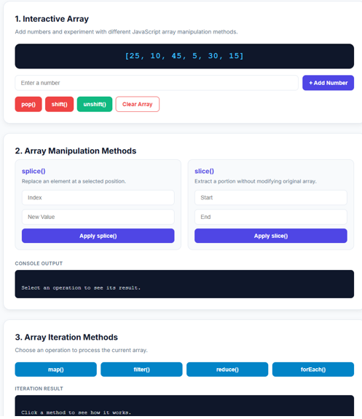

Result: The interactive array and loop demonstration system was successfully implemented and tested. The web interface correctly performs real-time array mutations (push(), pop(), shift(), unshift(), splice(), and slice()) and updates the displayed array dynamically. High-order iteration methods (map(), filter(), reduce(), and forEach()) execute correctly and present their transformed or aggregated outputs in the output console blocks. Additionally, the case study algorithm successfully evaluated the dataset [25, 10, 45, 5, 30, 15] using the .reduce() method, accurately returning 45 as the maximum value and 5 as the minimum value.

Experiment No 6
Aim: Use string function and regex for email validation, data extraction and text analysis
Theory: This practical demonstrates basic web development and text manipulation using HTML, CSS, and JavaScript. The user interface takes string inputs and processes them dynamically in real time using DOM manipulation and standard string methods. Regular Expressions (Regex) are used to search, pattern-match, and extract valid email addresses from unformatted text blocks. Built-in string methods like .toUpperCase(), .toLowerCase(), and .length enable instant case conversion and character counting. Word counts and targeted keyword tracking (e.g., detecting "welcome" and counting "email") are performed by splitting strings and using pattern matching (RegExp.prototype.test() and String.prototype.match()). Overall, the project demonstrates client-side data validation, text processing, and dynamic UI rendering without requiring page reloads.
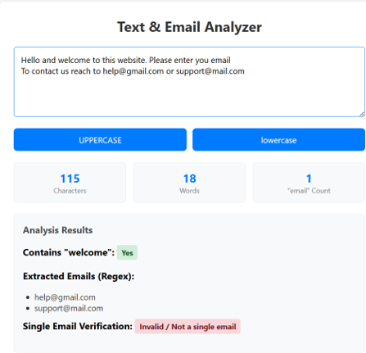
Result:
The developed web application successfully processes user input in real time. It accurately measures total character length and word count, detects the presence of the word "welcome", and counts occurrences of the word "email". Furthermore, the uppercase and lowercase transformation buttons dynamically reformat the text, while the Regular Expression engine correctly extracts all valid email addresses embedded in the text block and validates individual email formats.

Conclusion:
In conclusion, this practical successfully demonstrates the core concepts of client-side web development using HTML, CSS, and JavaScript. By integrating Regular Expressions with DOM manipulation and built-in JavaScript string functions, the application achieves dynamic, real-time text analysis and email validation. This highlights how front-end scripts can manipulate and validate user data instantly without requiring backend server processing or web page reloads.
Case Study 6
Aim:

<!DOCTYPE html>
<html lang="en">
<head>
<meta charset="UTF-8">
<meta name="viewport" content="width=device-width, initial-scale=1.0">
<title>JavaScript String Operations Lab</title>
<style>
:root {
--primary: #4f46e5;
--bg: #f8fafc;
--card: #ffffff;
--text: #1e293b;
--border: #e2e8f0;
}
body {
font-family: system-ui, -apple-system, sans-serif;
background-color: var(--bg);
color: var(--text);
margin: 0;
padding: 2rem;
display: flex;
justify-content: center;
}
.container {
max-width: 800px;
width: 100%;
}
h1, h2 {
color: var(--primary);
}
.section {
background: var(--card);
border: 1px solid var(--border);
border-radius: 8px;
padding: 1.5rem;
margin-bottom: 1.5rem;
box-shadow: 0 1px 3px rgba(0,0,0,0.1);
}
.form-group {
margin-bottom: 1rem;
}
label {
display: block;
font-weight: 600;
margin-bottom: 0.5rem;
}
input[type="text"], textarea {
width: 100%;
padding: 0.75rem;
border: 1px solid var(--border);
border-radius: 4px;
box-sizing: border-box;
font-size: 1rem;
}
button {
background-color: var(--primary);
color: white;
border: none;
padding: 0.75rem 1.5rem;
border-radius: 4px;
cursor: pointer;
font-size: 1rem;
font-weight: 500;
}
button:hover {
opacity: 0.9;
}
.output-box {
background: #f1f5f9;
padding: 1rem;
border-left: 4px solid var(--primary);
margin-top: 1rem;
border-radius: 0 4px 4px 0;
}
pre {
margin: 0;
white-space: pre-wrap;
font-family: monospace;
}
</style>
</head>
<body>

<div class="container">
<h1>JavaScript String Operations</h1>

<!-- Part A & B: Basics & Methods -->
<div class="section">
<h2>a & b) Basics and Built-in Methods</h2>
<div class="form-group">
<label for="mainString">Input String:</label>
<input type="text" id="mainString" value="Hello, JavaScript World!">
</div>
<button onclick="runStringMethods()">Run Methods</button>

<div class="output-box">
<strong>Results:</strong>
<pre id="methodsOutput">Click "Run Methods" to see the output.</pre>
</div>
</div>

<!-- Case Study 1: Reverse String -->
<div class="section">
<h2>Case Study 1: Reverse a String</h2>
<div class="form-group">
<label for="reverseInput">Enter text to reverse:</label>
<input type="text" id="reverseInput" value="Developer">
</div>
<button onclick="runReverseString()">Reverse</button>

<div class="output-box">
<strong>Reversed Output:</strong>
<pre id="reverseOutput">-</pre>
</div>
</div>

<!-- Case Study 2: Count Vowels -->
<div class="section">
<h2>Case Study 2: Count Vowels in Paragraph</h2>
<div class="form-group">
<label for="vowelInput">Enter paragraph:</label>
<textarea id="vowelInput" rows="4">The quick brown fox jumps over the lazy dog.</textarea>
</div>
<button onclick="runCountVowels()">Count Vowels</button>

<div class="output-box">
<strong>Vowel Counts:</strong>
<pre id="vowelOutput">-</pre>
</div>
</div>
</div>

<script>
// ==========================================
// a) Basics & b) Built-in Methods
// ==========================================
function runStringMethods() {
const str = document.getElementById('mainString').value;

// a) Basics
const length = str.length; // Property to get size
const firstChar = str[0]; // Accessing index

// b) Methods
const sub = str.substring(7, 17); // Extracts characters between index 7 and 17
const idx = str.indexOf('Java'); // Finds starting index of search term (-1 if not found)
const spl = str.split(' '); // Splits string into an array by space separator
const rep = str.replace('World', 'Universe'); // Replaces first matching text

// Format layout for display
document.getElementById('methodsOutput').textContent =
`Original String: "${str}"\n\n` +
`[Basics] Length: ${length}\n` +
`[Basics] Character at index 0: "${firstChar}"\n` +
`[substring(7, 17)]: "${sub}"\n` +
`[indexOf('Java')]: ${idx}\n` +
`[split(' ')]: ${JSON.stringify(spl)}\n` +
`[replace('World', 'Universe')]: "${rep}"`;
}

// ==========================================
// Case Study 1: Reverse a String
// ==========================================
function reverseString(text) {
// 1. split('') breaks the string into an array of characters
// 2. reverse() reverses the array in-place
// 3. join('') stitches the array elements back into a string
return text.split('').reverse().join('');
}

function runReverseString() {
const input = document.getElementById('reverseInput').value;
const result = reverseString(input);
document.getElementById('reverseOutput').textContent = result;
}

// ==========================================
// Case Study 2: Count Vowels
// ==========================================
function countVowels(paragraph) {
const vowels = 'aeiouAEIOU';
let count = 0;
let details = { a: 0, e: 0, i: 0, o: 0, u: 0 };

// Loop through every character in the string
for (let char of paragraph) {
if (vowels.includes(char)) {
count++;
let lowerChar = char.toLowerCase();
details[lowerChar] = (details[lowerChar] || 0) + 1;
}
}
return { total: count, details: details };
}

function runCountVowels() {
const input = document.getElementById('vowelInput').value;
const result = countVowels(input);

document.getElementById('vowelOutput').textContent =
`Total Vowels Found: ${result.total}\n` +
`Breakdown: ${JSON.stringify(result.details)}`;
}
</script>

</body>
</html>
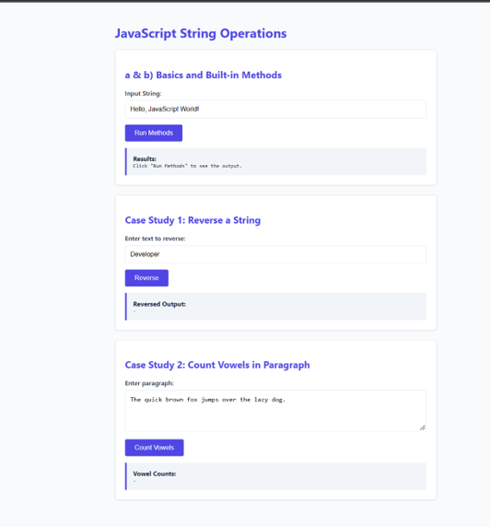

Result:
This experiment demonstrated the effective handling of string data types and manipulation methods in JavaScript. Using built-in methods like .substring(), .split(), and .replace() simplified string searching and parsing without modifying original immutable string variables. Furthermore, combining array techniques and iterative loop checks proved effective for solving practical text processing problems like reversing character sequences and tallying specific target characters.

Experiment 07
Aim: Perform DOM traversal and updates, develop a to-do list app with add, edit and delete features.
Theory:
This practical demonstrates client-side DOM (Document Object Model) manipulation, traversal, and event handling by building a dynamic, interactive To-Do list application. It leverages Event Delegation by attaching single click and change listeners to the parent <ul> container rather than individual ite ms, capturing events as they bubble up from child elements (event.target). Upward DOM traversal is performed using .closest('li') to identify parent task rows, while downward target selection uses .querySelector() to target and mutate descendant nodes. Real-time updates—such as dynamically inserting new elements (appendChild), replacing elements via .innerHTML for inline editing, removing elements with .remove(), and toggling CSS classes for task completion—are achieved smoothly without requiring server calls or page reloads.

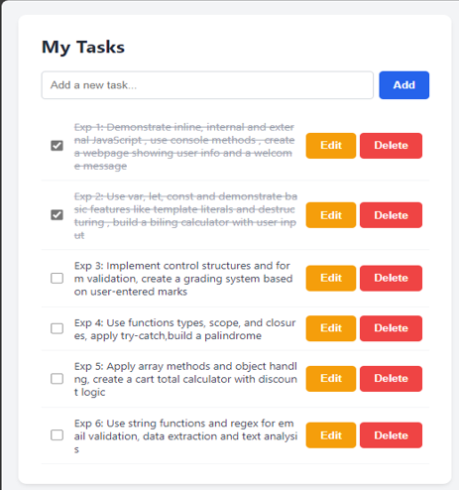
Result:
The To-Do application successfully performs real-time client-side task management with full CRUD capability without requiring page reloads. Users can dynamically generate new task items, edit existing task text through an inline input field, delete items instantly from the DOM tree, and toggle completion states via checkboxes to visually strike through finished tasks.
Conclusion:
In conclusion, this project effectively validates the core principles of front-end JavaScript DOM manipulation, traversal, and event handling. By utilizing event delegation on a single parent element and targeting relative nodes using Element.closest() and Element.querySelector(), the application maintains high performance, clean memory management, and smooth interactive updates for dynamically generated elements.

Case Study 07
Aim: To demonstrate the events handling in javascript
a)Access and manipulate form elements using js.
b) Validate user inputs(e.g. Email, empty fields).
c) Use various form events (submit,change,focus)
Create the following html form and use required js and events in a given form (first name, last name, email, birthday, password, reenter password, agree to the terms and conditions)
<!DOCTYPE html>
<html lang="en">
<head>
<meta charset="UTF-8">
<meta name="viewport" content="width=device-width, initial-scale=1.0">
<title>Registration Form - Case Study 7</title>
<!-- Google Fonts for modern typography -->
<link href="https://fonts.googleapis.com/css2?family=Inter:wght@400;500;600;700&display=swap" rel="stylesheet">

<style>
:root {
--primary: #6366f1;
--primary-hover: #4f46e5;
--bg-body: #0f172a;
--card-bg: #1e293b;
--text-main: #f8fafc;
--text-muted: #94a3b8;
--border: #334155;
--focus-bg: #1e293b;
--error: #ef4444;
--success: #10b981;
--radius: 10px;
}

* {
box-sizing: border-box;
}

body {
font-family: 'Inter', -apple-system, sans-serif;
margin: 0;
background: radial-gradient(circle at top left, #1e1b4b, var(--bg-body));
color: var(--text-main);
display: flex;
justify-content: center;
align-items: center;
min-height: 100vh;
padding: 20px;
}

.form-container {
width: 100%;
max-width: 520px;
background: var(--card-bg);
padding: 36px 32px;
border-radius: 16px;
box-shadow: 0 10px 25px -5px rgba(0, 0, 0, 0.4), 0 8px 10px -6px rgba(0, 0, 0, 0.2);
border: 1px solid var(--border);
}

.form-header {
text-align: center;
margin-bottom: 28px;
}

.form-header h2 {
margin: 0 0 6px 0;
font-size: 24px;
font-weight: 700;
letter-spacing: -0.5px;
}

.form-header p {
margin: 0;
color: var(--text-muted);
font-size: 14px;
}

.form-row {
display: grid;
grid-template-columns: 1fr 1fr;
gap: 16px;
}

.form-group {
margin-bottom: 18px;
}

label {
display: block;
margin-bottom: 6px;
font-size: 13px;
font-weight: 600;
color: #cbd5e1;
text-transform: uppercase;
letter-spacing: 0.5px;
}

input[type="text"],
input[type="password"],
input[type="date"] {
width: 100%;
padding: 12px 14px;
background-color: #0f172a;
border: 1px solid var(--border);
border-radius: var(--radius);
font-size: 14px;
color: var(--text-main);
outline: none;
transition: all 0.2s ease-in-out;
}

/* Focus styling updated to work cleanly with dark theme */
input:focus {
border-color: var(--primary);
box-shadow: 0 0 0 3px rgba(99, 102, 241, 0.2);
}

/* Inverted date picker icon color for dark mode */
input[type="date"]::-webkit-calendar-picker-indicator {
filter: invert(1);
cursor: pointer;
}

.error {
display: block;
color: var(--error);
font-size: 12px;
margin-top: 5px;
font-weight: 500;
}

.terms {
display: flex;
align-items: center;
gap: 10px;
margin-top: 10px;
margin-bottom: 4px;
}

.terms input[type="checkbox"] {
width: 18px;
height: 18px;
accent-color: var(--primary);
cursor: pointer;
}

.terms label {
margin: 0;
font-weight: 400;
text-transform: none;
color: var(--text-muted);
font-size: 14px;
cursor: pointer;
}

button[type="submit"] {
width: 100%;
padding: 13px;
margin-top: 22px;
background: linear-gradient(135deg, var(--primary), var(--primary-hover));
color: white;
border: none;
border-radius: var(--radius);
font-size: 15px;
font-weight: 600;
cursor: pointer;
transition: transform 0.15s ease, box-shadow 0.15s ease;
}

button[type="submit"]:hover {
transform: translateY(-1px);
box-shadow: 0 4px 12px rgba(99, 102, 241, 0.35);
}

#successMessage {
text-align: center;
color: var(--success);
font-weight: 600;
margin-top: 16px;
font-size: 14px;
}

@media (max-width: 480px) {
.form-row {
grid-template-columns: 1fr;
}
}
</style>
</head>
<body>

<div class="form-container">
<div class="form-header">
<h2>Create an Account</h2>
<p>Fill out the form details below to register</p>
</div>

<form id="registrationForm">
<div class="form-row">
<div class="form-group">
<label for="firstName">First Name</label>
<input type="text" id="firstName" placeholder="Enter first name">
<span class="error" id="firstNameError"></span>
</div>
<div class="form-group">
<label for="lastName">Last Name</label>
<input type="text" id="lastName" placeholder="Enter last name">
<span class="error" id="lastNameError"></span>
</div>
</div>

<div class="form-group">
<label for="email">Email</label>
<input type="text" id="email" placeholder="example@gmail.com">
<span class="error" id="emailError"></span>
</div>

<div class="form-group">
<label for="birthday">Birthday</label>
<input type="date" id="birthday">
<span class="error" id="birthdayError"></span>
</div>

<div class="form-group">
<label for="password">Password</label>
<input type="password" id="password" placeholder="Enter password">
<span class="error" id="passwordError"></span>
</div>

<div class="form-group">
<label for="rePassword">Re-enter Password</label>
<input type="password" id="rePassword" placeholder="Re-enter password">
<span class="error" id="rePasswordError"></span>
</div>

<div class="terms">
<input type="checkbox" id="terms">
<label for="terms">I agree to the Terms and Conditions</label>
</div>
<span class="error" id="termsError"></span>

<button type="submit">Register</button>
<p id="successMessage"></p>
</form>
</div>

<script>
// Form & Field DOM Access
const form = document.getElementById("registrationForm");
const firstName = document.getElementById("firstName");
const lastName = document.getElementById("lastName");
const email = document.getElementById("email");
const birthday = document.getElementById("birthday");
const password = document.getElementById("password");
const rePassword = document.getElementById("rePassword");
const terms = document.getElementById("terms");

// Error Message DOM Access
const firstNameError = document.getElementById("firstNameError");
const lastNameError = document.getElementById("lastNameError");
const emailError = document.getElementById("emailError");
const birthdayError = document.getElementById("birthdayError");
const passwordError = document.getElementById("passwordError");
const rePasswordError = document.getElementById("rePasswordError");
const termsError = document.getElementById("termsError");
const successMessage = document.getElementById("successMessage");

// Focus Events (Highlight field background)
const textInputs = [firstName, lastName, email, password, rePassword];
textInputs.forEach(input => {
input.addEventListener("focus", function () {
input.style.backgroundColor = "#1e293b";
});
});

// Change Events for Live Checks
email.addEventListener("change", function () {
const emailValue = email.value.trim();
const emailPattern = /^[^\s@]+@[^\s@]+\.[^\s@]+$/;
if (emailValue === "") {
emailError.textContent = "Email is required.";
emailError.style.color = "#ef4444";
} else if (!emailPattern.test(emailValue)) {
emailError.textContent = "Please enter a valid email address.";
emailError.style.color = "#ef4444";
} else {
emailError.textContent = "Valid email address.";
emailError.style.color = "#10b981";
}
});

password.addEventListener("change", function () {
if (password.value.length < 6) {
passwordError.textContent = "Password must contain at least 6 characters.";
} else {
passwordError.textContent = "";
}
});

rePassword.addEventListener("change", function () {
if (rePassword.value !== password.value) {
rePasswordError.textContent = "Passwords do not match.";
} else {
rePasswordError.textContent = "";
}
});

// Form Submit Event (Full Validation Check)
form.addEventListener("submit", function (event) {
event.preventDefault();

// Clear previous errors
firstNameError.textContent = "";
lastNameError.textContent = "";
emailError.textContent = "";
birthdayError.textContent = "";
passwordError.textContent = "";
rePasswordError.textContent = "";
termsError.textContent = "";
successMessage.textContent = "";

let isValid = true;

if (firstName.value.trim() === "") {
firstNameError.textContent = "First name is required.";
isValid = false;
}

if (lastName.value.trim() === "") {
lastNameError.textContent = "Last name is required.";
isValid = false;
}

const emailValue = email.value.trim();
const emailPattern = /^[^\s@]+@[^\s@]+\.[^\s@]+$/;
if (emailValue === "") {
emailError.textContent = "Email is required.";
emailError.style.color = "#ef4444";
isValid = false;
} else if (!emailPattern.test(emailValue)) {
emailError.textContent = "Please enter a valid email address.";
emailError.style.color = "#ef4444";
isValid = false;
}

if (birthday.value === "") {
birthdayError.textContent = "Birthday is required.";
isValid = false;
}

if (password.value === "") {
passwordError.textContent = "Password is required.";
isValid = false;
} else if (password.value.length < 6) {
passwordError.textContent = "Password must contain at least 6 characters.";
isValid = false;
}

if (rePassword.value === "") {
rePasswordError.textContent = "Please re-enter your password.";
isValid = false;
} else if (password.value !== rePassword.value) {
rePasswordError.textContent = "Passwords do not match.";
isValid = false;
}

if (!terms.checked) {
termsError.textContent = "You must agree to the Terms and Conditions.";
isValid = false;
}

if (isValid) {
successMessage.textContent = "Registration successful!";
form.reset();
}
});
</script>
</body>
</html>

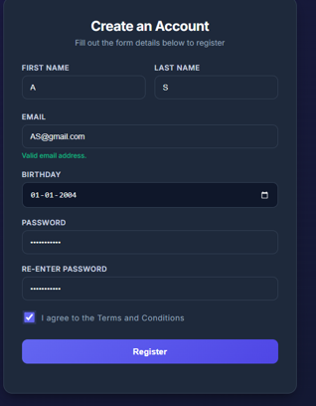

Result:
The registration form was successfully created with JavaScript event handling and input validation for email, password, required fields, and terms acceptance. The application dynamically processes user focus and input changes, provides instant error feedback, and confirms completion with a "Registration successful!" message upon valid submission.
Experiment 08
Aim: Access and validate form fields using events. Design a gym admission form with live input checks.
Theory:
JavaScript event listeners enable interactive, real-time user validation by monitoring form events such as input (triggers on every keystroke) and change (triggers when a selection changes). By attaching listeners to input elements, JavaScript can intercept user inputs immediately, apply regular expression pattern checks or boundary logic, and provide instant visual feedback. Accessing DOM element values directly using document.getElementById() allows developers to validate data client-side before form submission. This approach prevents invalid submissions, improves data accuracy, and creates a responsive user experience by giving instant feedback without full-page reloads
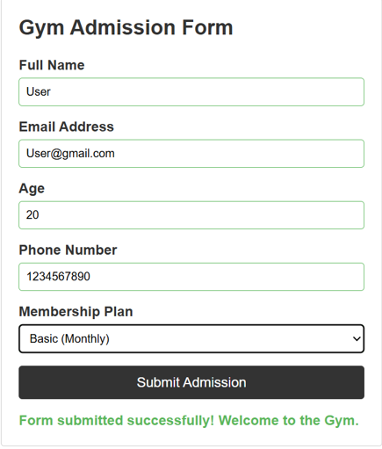.
Result:
The Gym Admission Form with live input checks was successfully built using HTML, CSS, and JavaScript event handlers. The application continuously monitors user actions across five fields (Full Name, Email Address, Age, Phone Number, and Membership Plan). Real-time validation correctly highlights input borders green for valid entries and red for errors, displays instant contextual error messages, and keeps the submission button disabled until all constraints are met.
Conclusion:
This experiment demonstrated the practical implementation of DOM field access and event-driven form validation in JavaScript. Using real-time event listeners (input and change) proved significantly more user-friendly than traditional form submission checks. Client-side input validation effectively ensures data integrity, improves application responsiveness, and eliminates invalid form submissions prior to server processing.

Case Study 8
Aim:
<!DOCTYPE html>
<html lang="en">
<head>
<meta charset="UTF-8">
<meta name="viewport" content="width=device-width, initial-scale=1.0">
<title>Job Application Form</title>
<style>
:root {
--primary: #2563eb;
--primary-hover: #1d4ed8;
--error: #dc2626;
--success: #16a34a;
--bg: #f8fafc;
--card-bg: #ffffff;
--text: #1e293b;
--border: #cbd5e1;
}

* { box-sizing: border-box; margin: 0; padding: 0; font-family: 'Segoe UI', system-ui, sans-serif; }

body {
background-color: var(--bg);
color: var(--text);
line-height: 1.6;
padding: 20px;
}

.container {
max-width: 800px;
margin: 0 auto;
background: var(--card-bg);
padding: 30px;
border-radius: 12px;
box-shadow: 0 4px 6px -1px rgba(0, 0, 0, 0.1);
}

h1 { text-align: center; color: var(--primary); margin-bottom: 10px; }
.subtitle { text-align: center; color: #64748b; margin-bottom: 30px; font-size: 0.95rem; }

fieldset {
border: 1px solid var(--border);
border-radius: 8px;
padding: 20px;
margin-bottom: 25px;
}

legend {
font-weight: 600;
font-size: 1.1rem;
color: var(--primary);
padding: 0 10px;
}

.form-grid {
display: grid;
grid-template-columns: 1fr 1fr;
gap: 15px;
}

.form-group {
display: flex;
flex-direction: column;
margin-bottom: 15px;
}

.form-group.full-width { grid-column: 1 / -1; }

label {
font-weight: 500;
margin-bottom: 5px;
font-size: 0.9rem;
}

.required { color: var(--error); }

input, select, textarea {
padding: 10px 12px;
border: 1px solid var(--border);
border-radius: 6px;
font-size: 1rem;
transition: border-color 0.2s, box-shadow 0.2s;
width: 100%;
}

input:focus, select:focus, textarea:focus {
outline: none;
border-color: var(--primary);
box-shadow: 0 0 0 3px rgba(37, 99, 235, 0.1);
}

/* Validation States */
input.invalid, select.invalid, textarea.invalid {
border-color: var(--error);
background-color: #fef2f2;
}

input.valid, select.valid, textarea.valid {
border-color: var(--success);
}

.error-message {
color: var(--error);
font-size: 0.8rem;
margin-top: 4px;
min-height: 18px;
display: block;
}

textarea { resize: vertical; min-height: 80px; }

.btn-submit {
width: 100%;
padding: 14px;
background-color: var(--primary);
color: white;
border: none;
border-radius: 8px;
font-size: 1.1rem;
font-weight: 600;
cursor: pointer;
transition: background-color 0.2s;
margin-top: 10px;
}

.btn-submit:hover { background-color: var(--primary-hover); }
.btn-submit:disabled { background-color: #94a3b8; cursor: not-allowed; }

.success-msg {
display: none;
background-color: #dcfce7;
color: var(--success);
padding: 15px;
border-radius: 8px;
text-align: center;
font-weight: 600;
margin-top: 20px;
}

@media (max-width: 600px) {
.form-grid { grid-template-columns: 1fr; }
.container { padding: 15px; }
}
</style>
</head>
<body>

<div class="container">
<h1>Job Application Form</h1>
<p class="subtitle">Please fill in your details accurately. Fields marked with <span class="required">*</span> are mandatory.</p>

<form id="jobApplicationForm" novalidate>
<!-- Personal Information -->
<fieldset>
<legend>Personal Information</legend>
<div class="form-grid">
<div class="form-group full-width">
<label for="fullName">Full Name <span class="required">*</span></label>
<input type="text" id="fullName" name="fullName" placeholder="e.g., John Doe" required>
<span class="error-message" id="fullNameError"></span>
</div>
<div class="form-group">
<label for="dob">Date of Birth <span class="required">*</span></label>
<input type="date" id="dob" name="dob" required>
<span class="error-message" id="dobError"></span>
</div>
<div class="form-group">
<label for="gender">Gender <span class="required">*</span></label>
<select id="gender" name="gender" required>
<option value="">Select Gender</option>
<option value="Male">Male</option>
<option value="Female">Female</option>
<option value="Other">Other</option>
<option value="Prefer not to say">Prefer not to say</option>
</select>
<span class="error-message" id="genderError"></span>
</div>
<div class="form-group">
<label for="email">Email Address <span class="required">*</span></label>
<input type="email" id="email" name="email" placeholder="example@domain.com" required>
<span class="error-message" id="emailError"></span>
</div>
<div class="form-group">
<label for="mobile">Mobile Number <span class="required">*</span></label>
<input type="tel" id="mobile" name="mobile" placeholder="10-digit number" maxlength="10" required>
<span class="error-message" id="mobileError"></span>
</div>
<div class="form-group full-width">
<label for="address">Address <span class="required">*</span></label>
<textarea id="address" name="address" placeholder="Street address, apartment, etc." required></textarea>
<span class="error-message" id="addressError"></span>
</div>
<div class="form-group">
<label for="city">City <span class="required">*</span></label>
<input type="text" id="city" name="city" required>
<span class="error-message" id="cityError"></span>
</div>
<div class="form-group">
<label for="state">State <span class="required">*</span></label>
<input type="text" id="state" name="state" required>
<span class="error-message" id="stateError"></span>
</div>
<div class="form-group">
<label for="pincode">PIN Code <span class="required">*</span></label>
<input type="text" id="pincode" name="pincode" placeholder="6-digit PIN" maxlength="6" required>
<span class="error-message" id="pincodeError"></span>
</div>
</div>
</fieldset>

<!-- Educational Qualification -->
<fieldset>
<legend>Educational Qualification</legend>
<div class="form-grid">
<div class="form-group">
<label for="qualification">Highest Qualification <span class="required">*</span></label>
<select id="qualification" name="qualification" required>
<option value="">Select Qualification</option>
<option value="High School">High School</option>
<option value="Diploma">Diploma</option>
<option value="Bachelor's">Bachelor's Degree</option>
<option value="Master's">Master's Degree</option>
<option value="Ph.D.">Ph.D.</option>
</select>
<span class="error-message" id="qualificationError"></span>
</div>
<div class="form-group">
<label for="university">University / Institute <span class="required">*</span></label>
<input type="text" id="university" name="university" required>
<span class="error-message" id="universityError"></span>
</div>
<div class="form-group">
<label for="passingYear">Passing Year <span class="required">*</span></label>
<input type="number" id="passingYear" name="passingYear" placeholder="e.g., 2023" min="1980" max="2030" required>
<span class="error-message" id="passingYearError"></span>
</div>
<div class="form-group">
<label for="cgpa">CGPA / Percentage <span class="required">*</span></label>
<input type="number" id="cgpa" name="cgpa" placeholder="e.g., 8.5" step="0.01" min="0" max="100" required>
<span class="error-message" id="cgpaError"></span>
</div>
</div>
</fieldset>

<!-- Professional Information -->
<fieldset>
<legend>Professional Information</legend>
<div class="form-grid">
<div class="form-group">
<label for="jobPosition">Applying For / Job Position <span class="required">*</span></label>
<input type="text" id="jobPosition" name="jobPosition" placeholder="e.g., Software Engineer" required>
<span class="error-message" id="jobPositionError"></span>
</div>
<div class="form-group">
<label for="experience">Total Work Experience (Years) <span class="required">*</span></label>
<input type="number" id="experience" name="experience" placeholder="e.g., 3" min="0" max="50" required>
<span class="error-message" id="experienceError"></span>
</div>
<div class="form-group full-width">
<label for="organization">Current / Previous Organization <span class="required">*</span></label>
<input type="text" id="organization" name="organization" required>
<span class="error-message" id="organizationError"></span>
</div>
<div class="form-group">
<label for="expectedSalary">Expected Salary (Annual) <span class="required">*</span></label>
<input type="number" id="expectedSalary" name="expectedSalary" placeholder="e.g., 800000" min="0" required>
<span class="error-message" id="expectedSalaryError"></span>
</div>
</div>
</fieldset>

<!-- Technical Skills -->
<fieldset>
<legend>Technical Skills</legend>
<div class="form-grid">
<div class="form-group full-width">
<label for="programmingSkills">Programming Skills <span class="required">*</span></label>
<textarea id="programmingSkills" name="programmingSkills" placeholder="e.g., Java, Python, C++, JavaScript" required></textarea>
<span class="error-message" id="programmingSkillsError"></span>
</div>
<div class="form-group full-width">
<label for="certifications">Certifications</label>
<textarea id="certifications" name="certifications" placeholder="e.g., AWS Certified, Oracle Java SE (Optional)"></textarea>
<span class="error-message" id="certificationsError"></span>
</div>
</div>
</fieldset>

<button type="submit" class="btn-submit" id="submitBtn">Submit Application</button>
<div class="success-msg" id="successMsg">✅ Application submitted successfully! We will contact you soon.</div>
</form>
</div>

<script>
// Utility function to show error
function showError(inputId, message) {
const input = document.getElementById(inputId);
const errorSpan = document.getElementById(inputId + 'Error');
input.classList.add('invalid');
input.classList.remove('valid');
if (errorSpan) errorSpan.textContent = message;
}

// Utility function to clear error / show success
function clearError(inputId) {
const input = document.getElementById(inputId);
const errorSpan = document.getElementById(inputId + 'Error');
input.classList.remove('invalid');
input.classList.add('valid');
if (errorSpan) errorSpan.textContent = '';
}

// Validation Rules
const validators = {
fullName: (val) => {
if (!val.trim()) return "Full name is required.";
if (val.trim().length < 3) return "Name must be at least 3 characters.";
if (!/^[a-zA-Z\s]+$/.test(val)) return "Name should only contain letters.";
return "";
},
dob: (val) => {
if (!val) return "Date of birth is required.";
const dob = new Date(val);
const today = new Date();
let age = today.getFullYear() - dob.getFullYear();
const m = today.getMonth() - dob.getMonth();
if (m < 0 || (m === 0 && today.getDate() < dob.getDate())) age--;
if (age < 18) return "You must be at least 18 years old.";
if (dob > today) return "Date of birth cannot be in the future.";
return "";
},
gender: (val) => !val ? "Please select a gender." : "",
email: (val) => {
if (!val) return "Email is required.";
const regex = /^[^\s@]+@[^\s@]+\.[^\s@]+$/;
return !regex.test(val) ? "Please enter a valid email address." : "";
},
mobile: (val) => {
if (!val) return "Mobile number is required.";
return !/^[0-9]{10}$/.test(val) ? "Enter a valid 10-digit mobile number." : "";
},
address: (val) => !val.trim() ? "Address is required." : "",
city: (val) => !val.trim() ? "City is required." : "",
state: (val) => !val.trim() ? "State is required." : "",
pincode: (val) => {
if (!val) return "PIN code is required.";
return !/^[0-9]{6}$/.test(val) ? "Enter a valid 6-digit PIN code." : "";
},
qualification: (val) => !val ? "Please select your highest qualification." : "",
university: (val) => !val.trim() ? "University name is required." : "",
passingYear: (val) => {
if (!val) return "Passing year is required.";
const year = parseInt(val);
const currentYear = new Date().getFullYear();
if (year < 1980 || year > currentYear) return `Year must be between 1980 and ${currentYear}.`;
return "";
},
cgpa: (val) => {
if (!val) return "CGPA/Percentage is required.";
const num = parseFloat(val);
if (num < 0 || num > 100) return "Enter a valid score (0 - 100).";
return "";
},
jobPosition: (val) => !val.trim() ? "Job position is required." : "",
experience: (val) => {
if (val === "") return "Work experience is required.";
if (parseInt(val) < 0) return "Experience cannot be negative.";
return "";
},
organization: (val) => !val.trim() ? "Organization name is required." : "",
expectedSalary: (val) => {
if (val === "") return "Expected salary is required.";
if (parseInt(val) < 0) return "Salary cannot be negative.";
return "";
},
programmingSkills: (val) => !val.trim() ? "Please list your programming skills." : ""
};

// Attach real-time validation to all inputs
Object.keys(validators).forEach(id => {
const element = document.getElementById(id);
if (element) {
// Validate on blur (when leaving the field) and input (while typing)
['blur', 'input'].forEach(eventType => {
element.addEventListener(eventType, () => {
const errorMsg = validators[id](element.value);
if (errorMsg) {
showError(id, errorMsg);
} else {
clearError(id);
}
});
});
}
});

// Form Submission Handling
document.getElementById('jobApplicationForm').addEventListener('submit', function(e) {
e.preventDefault(); // Prevent default submission

let isFormValid = true;
let firstInvalidField = null;

// Run all validators
Object.keys(validators).forEach(id => {
const element = document.getElementById(id);
const errorMsg = validators[id](element.value);

if (errorMsg) {
showError(id, errorMsg);
isFormValid = false;
if (!firstInvalidField) firstInvalidField = element;
} else {
clearError(id);
}
});

if (!isFormValid) {
// Scroll to the first error
firstInvalidField.scrollIntoView({ behavior: 'smooth', block: 'center' });
firstInvalidField.focus();
return;
}

// If valid, simulate submission
const submitBtn = document.getElementById('submitBtn');
submitBtn.disabled = true;
submitBtn.textContent = "Submitting...";

setTimeout(() => {
document.getElementById('successMsg').style.display = 'block';
submitBtn.textContent = "Submitted";
// In a real scenario, you would send the data to a server here using fetch() or AJAX
console.log("Form Data Submitted:", new FormData(this));
}, 1000);
});
</script>

</body>
</html>

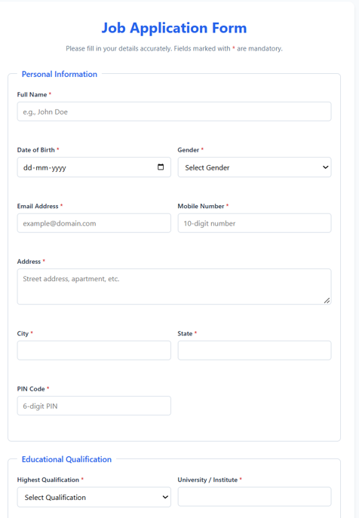
Result: This experiment demonstrated the end-to-end design and implementation of client-side form validation for a complex multi-section application form. Centralizing validation logic inside a structured JavaScript validators lookup object streamlined real-time input checks and DOM manipulation. Utilizing event-driven validation improves user feedback, preserves data integrity prior to form submission, and ensures a responsive user experience.
Experiment 09
Aim: Implement Local and Session storage to save user preferences like theme settings
Theory:
Web Storage API provides key-value storage mechanisms—localStorage and sessionStorage—that allow web applications to store data locally within the user's browser without sending it to a server. localStorage persists data permanently across browser sessions until explicitly cleared, making it ideal for storing long-term user preferences such as theme settings (dark/light mode). sessionStorage, on the other hand, maintains data only for the duration of the current page session and clears automatically when the browser tab or window closes. Data in Web Storage is stored as strings, requiring getItem(), setItem(), and removeItem() methods for manipulation. In this experiment, these storage mechanisms are implemented to save, retrieve, and automatically apply a user's selected theme preferences across page reloads and browser sessions.

Result: The theme preference manager was successfully implemented using localStorage and sessionStorage. The application accurately captures user input (such as toggling between light and dark themes), saves the selected state in the browser's web storage, and applies the preferred theme instantly via DOM manipulation. Upon reloading the page or reopening the tab, the application successfully retrieves the saved preference from storage and maintains the correct theme without manual reselection.
Conclusion: This experiment demonstrated the practical usage of the Web Storage API for managing client-side state and user preferences. Utilizing localStorage proved effective for maintaining persistent application states like theme modes across browser restarts, while sessionStorage demonstrated its utility for tab-bound temporary data. Implementing client-side storage reduces unnecessary server requests, speeds up initial page styling on load, and enhances overall user experience through persistent personalization.`

Experiment 10
Aim: Load and display JSON data using fetch() and jQuery$.getJSON(), render results dynamically in a table
Theory:
The JavaScript Fetch API and jQuery library provide robust asynchronous methods for retrieving and rendering structured data (such as JSON) dynamically on web pages without triggering a full page reload. Local JSON arrays allow client-side modeling of structured records, which can be queried asynchronously using JavaScript Promises or jQuery helper methods ($.each()). When data is fetched, DOM manipulation techniques iterate through the array to generate dynamic HTML table elements (<tr> and <td>), replacing static placeholders. Furthermore, integrating user feedback mechanisms—such as dynamic status text and loading indicators—ensures an asynchronous user experience by signaling data processing states during execution.
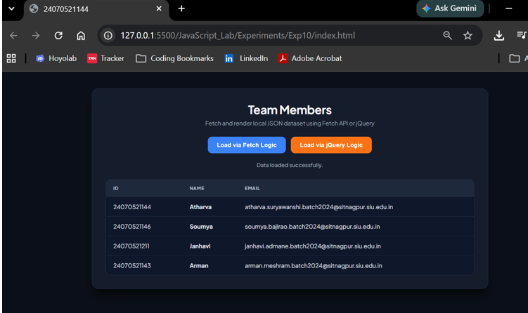
Result: The Local JSON Data Table application was successfully built and tested using both native JavaScript Fetch logic (simulated using Promises) and jQuery array iteration methods. Upon clicking either the "Load via Fetch Logic" or "Load via jQuery Logic" button, the application triggers a loading animation and updates the status message to indicate processing. After an artificial delay simulating a network request, the local JSON team dataset—containing member ID numbers, names, and official institutional email addresses—is dynamically parsed and injected into the target HTML table. Both methods consistently generated identical table structures, updated the status text to confirm successful data loading, and hid the loader once rendering was complete.
Conclusion: This experiment demonstrated the practical implementation of client-side data rendering using JavaScript Promises and jQuery. Simulating asynchronous retrieval highlighted how modern Web APIs and JS libraries process structured JSON data to dynamically update DOM elements without refreshing the web page. Both the Fetch API logic and jQuery methods proved effective for handling local data arrays, ensuring efficient data presentation and a seamless, responsive user interface.

